Assignment no 1:

Subject:MySQL

Name:Shantanu Koyalkar

1. To list all records with sal > 2000 and comm>200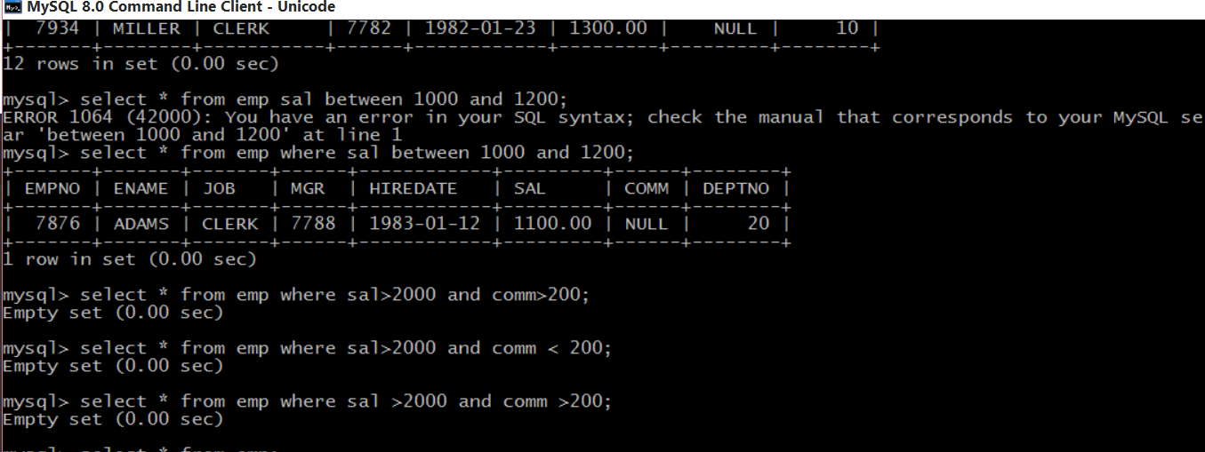

2. To list all record with job=’Clerk’ or sal>2000

3. To list all the record with sal=1250 or 1100 or 2850

4. To list all employees with sal>1250 and <2850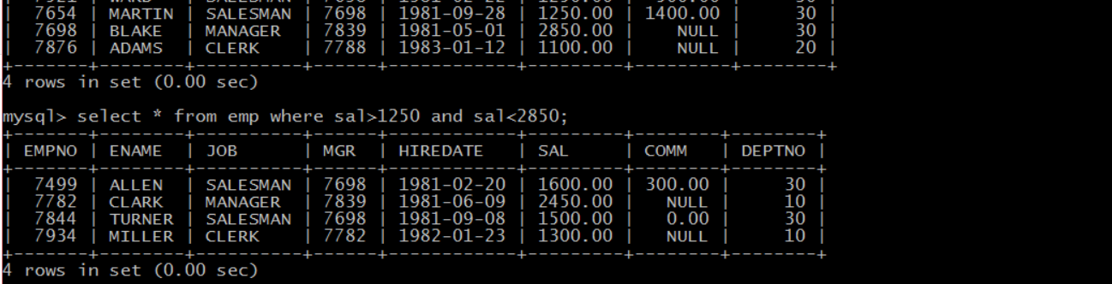

5. To list all employees with name ends with AS

6. To list all employees with job starts with C and ends with K

7. To list all employees with job contains L at third position and

M at third last position

8. To list all the record with sal not equal to 1250 or 1100 or 2850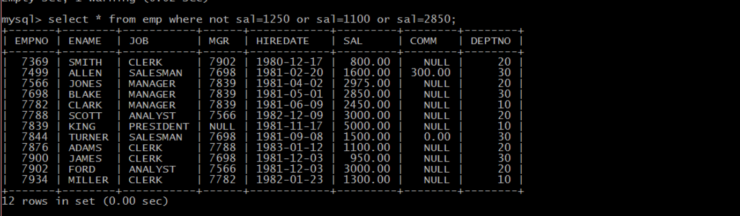

9. To list all employees with salnot >1250 and <2850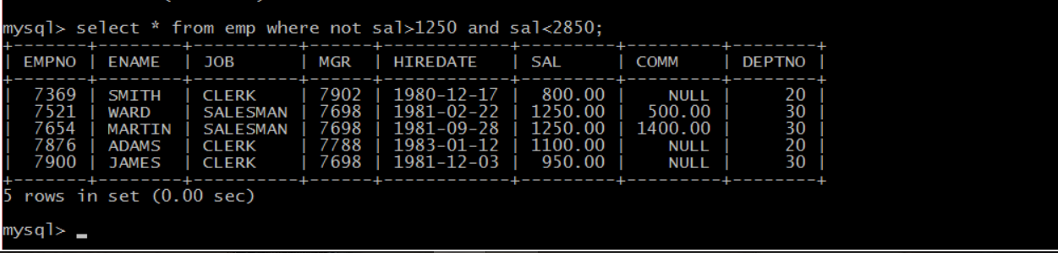

10. To list all employees with job starts with C , E at 3rd position and ends with K

11. To list all rows with comm is null

12. To list all employees with sal is null and name starts with ‘S’

13. To list all employees with job contains 5 characters

14. To list all employees with name contain ‘A’ at 1 position and job

Contains 5 characters

